[FROM USER]
… this topic generates a lot of questions!
“What happens if the first user tries to access the app again?”
[MY ANSWER]
Microsoft sees a user as active or not over a 30-day period. When a user accesses an app with the Per App license switch turn-on, they will be considered an active user.
So, for example, in your production environment “cfo-rma” as of today, you have 35 active users over the past 30 days that are showing Per App allocations.
Note in the screenshot below; the “Per User” licenses are the same as the “Power Apps Premium” license type, which shows 12 active users this month.
Remember, these stats are only for this environment, and only 5 days into the month, so your active users may increase.
The “cfo-rma” production has 210 app passes (Per App) licenses associated with the environment.
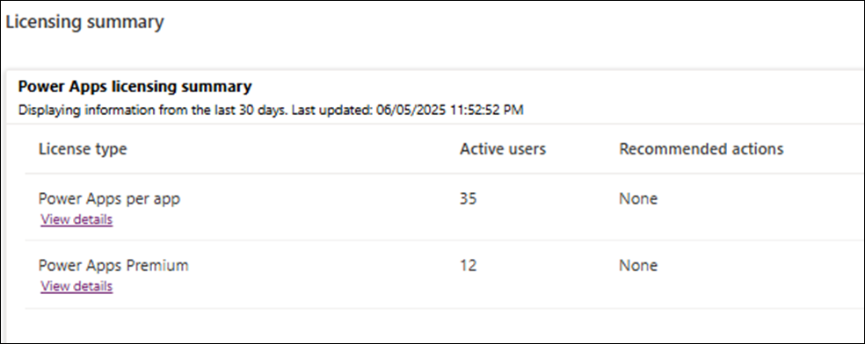

The “cfo-rma-uat” Sandbox has 40 app passes (Per App) licenses associated with the environment.
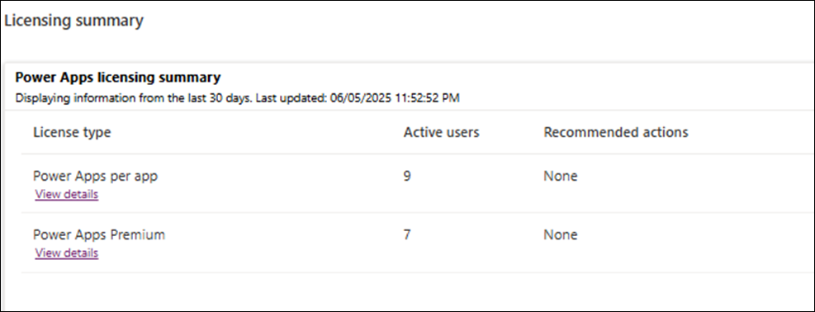
The reporting is not great as the link I sent yesterday mentioned in the note section. It is a “work” in progress.
Hopefully, the team can build new reporting tools that can easily share the above information with users like yourself soon.
[FROM USER]
Last question.
Once the user stops using the app for 30 days, the system sets the app pass to unallocated.
Then, when the app is shared with a new user, the license is re-allocated.
What happens if the first user tries to access the app again?
In the future, once our tool is more broadly used daily by our 200+ users, we would love to see if we are able to gather metrics on the average monthly user count to help optimize our license allocation and usage.
Thank you so much for your help!
[MY ANSWER]
This part is a little confusing.
Technically, the Per App licenses are assigned to Apps, specifically “properly configure” apps.
Once the user stops using the app for 30 days, the system sets the app pass to unallocated.
Then, when the app is shared with a new user, the license is re-allocated.
This will happen over-n-over, until all “Per-app” licenses previously applied to the environment are consumed within the month.

What I meant by “properly configure” can be explained using these two screen shots below.
To configure a specific app for “Per-app” licenses, right-click on the ellipses next to your app, then click settings.
NOTE: it is a good idea to turn this switch to OFF on apps not being used or needed so they don’t consume a license.
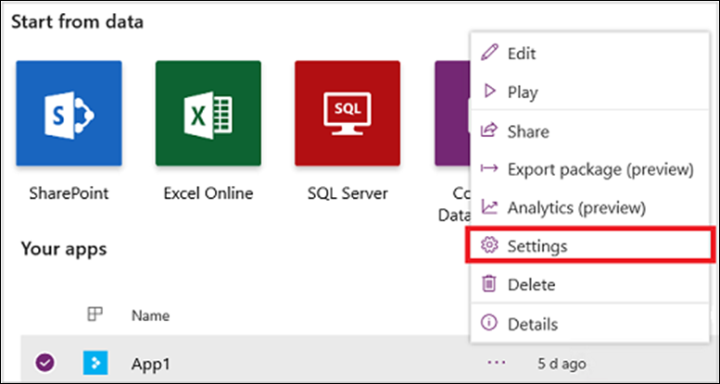
Under Per-app licensing, change the toggle to On. The toggle appears in all app settings.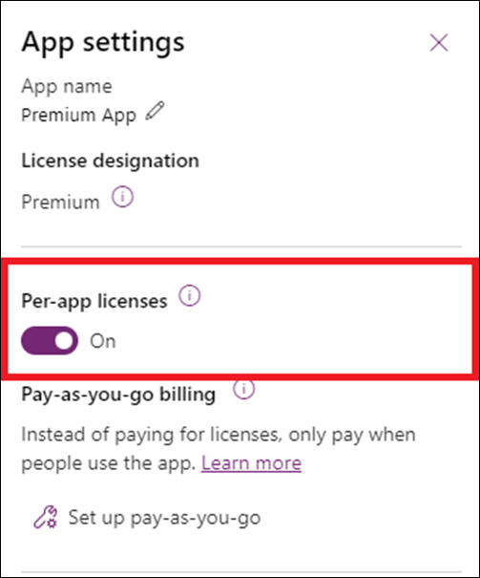
Here’s a link to the MS Learn page on this topic.
The section location link below shows a table example of how the consumption-of-per-app-licensing works across 3 environments.
About Power Apps per app plans - Power Platform | Microsoft Learn
[FROM USER]
Thank you, this is definitely helpful.
For Per App, as long as they have access to the environment and are an enabled user, they will have access (assuming there are enough licenses). While the Per App licenses are assigned to individual users initially, if the user hasn’t used the license within 30 days, at the start of the month, it will free up for the next person to use it.
But these don’t have to be assigned again, right? It’s just picked up by the next person who tried to access the app/environment?
The presentation will be nice! I would love to see it when its finalized.

Regarding your (Question for my understanding, if someone’s account is deactivated, does the assigned license automatically get pulled back from the account.)
It depends on the license type, i.e., “Per User” vs “Per App” that is allocated to the user.
For the “Per App” (aka App Pass), the license is associated with app in the specified environment. These licenses reset every 30 days at the beginning of the month.
If user has not interacted with the app within the month, the license allocation is free to be re-allocated by the next enabled user sharing the app.
The “Per User” is different and follows the user in all environments they have access within our tenant.
The premium licenses are added or removed by including or removing users in your license group: RM&A License User Group = dyn-cfo-rma-user
If an account is deactivated (disabled) in an environment, it is typically done by removing a user from the Security Group. (see your prod group below)
That is how we control who is active or not in environments. That is also how your “Per App” are allocated or shared by users.
That is also why the user count in an environment should match the amount of App Passes that have been applied to the environment.
I am working on a slide presentation on this topic and strategies for optimizing licenses that I will be happy share with you when completed.
I hope this helps your understanding a little bit for now.

